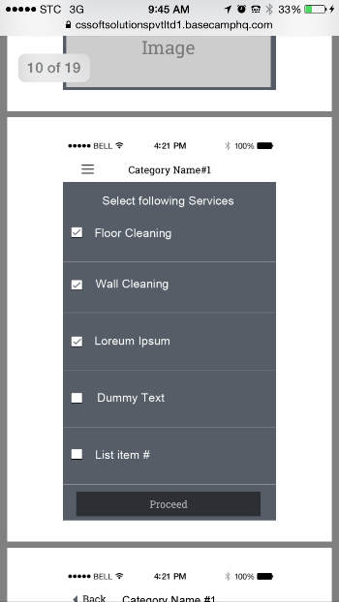
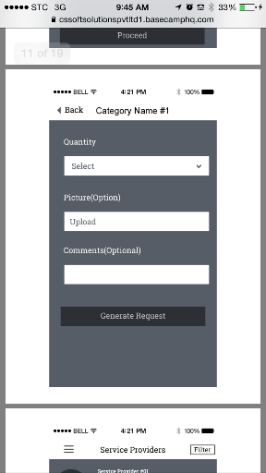
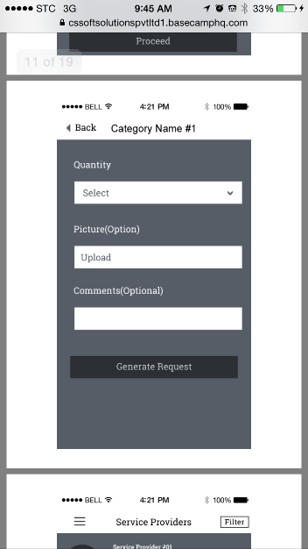
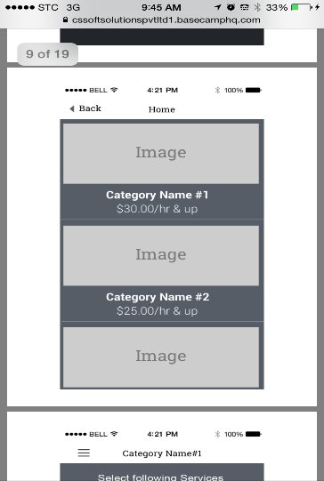
Services Provided Comments 24 10 2015
I have attached or you a modified Services Provide excel sheet for better understanding:

1. You have specified 7 services in top page of excel sheet shared above.
And in Category - "General Handyman" there are 13 services listed down in excel sheet.
Do we need to track only 7 services listed above?

CSSOFT Comments : 26/10/2015

1. Below explanation is clear but still question is not addressed, please check in excel sheet you have listed down 7 sub services price with minimum visit duration. And below you have listed 13 subservices,'

Now you have mentioned that we will use 13 sub services in case of general handyman then in that case what will be price and minimum visit duration for remaining sub services:

1. Home Appliances
2. Elevators
3. Door & Windows
4. Cleaning
5. Other Services
- Handyman Deliveries
I believe you are talking about this
Tasks | Minimum Visit Duration: | Price
Plumping | 2 hours | SR.250
Electrical | 2 hours | SR.250
Air Conditioning | 2 hours | SR.300
Pest Control | 2 hours | SR.150
Water tanks | 2 hours | SR.200
Pool Services | 2 hours | SR.150
landscaping Services | 2 hours | SR.100
This is actually as an example to the service providers, it is not related to you. And below I wil explain it in details I will take couple of samples and the rest will be the same.

We have 6 main categories as per the excel sheet that will show in the main category
- General handyman
  - Plumping
 | Price | visit rate
Fix Blockage | 0 | 0
Fix Leakage | 0 | 0
Fix Faucet | 0 | 0
Fix Sinks | 0 | 0
Fix Water Pressure | 0 | 0
Fix water spray | 0 | 0
Fix Toilet Seat | 0 | 0
Fix Shower | 0 | 0
Fix Water Heater & Cooler | 0 | 0
Fix Water Pump | 0 | 0
Replace water spray | 0 | 0
Replace Toilet Seat | 0 | 0
Replace Shower | 0 | 0
replace Water Heater & Cooler | 0 | 0
Replace Water Pump | 0 | 0

That shows that the prices will be inputted by the service providers and shown to the client are based on the actual service not the subservice. And in this case of General handy man it will be based and shown to the clients as the price per visit.

The same applies to all subservice and atual services under general handy man.

- General Moving
  - You can see in this categories and all other categories to follow, we do not have subservices, we have direct services which shows that the prices will be inputted by the service providers and shown to the client are based on the actual service not the subservice. And in this case of General moving it will be based and shown to the clients as the price per Hour.
 | Price | Hourly rate
In city moving | 75 | 1
out of city moving | 75 | 1
Furniture Moving | 75 | 1
Furniture Storing | 75 | 1

- ASSEMBLE & Disassembly of FURNITURE
  - You can see in this categories and all other categories to follow, we do not have subservices, we have direct services which shows that the prices will be inputted by the service providers and shown to the client are based on the actual service not the subservice. And in this case of ASSEMBLE & Disassembly of FURNITURE it will be based and shown to the clients as the price per Hour.
 | Price | Hourly rate
Assembly & Disassembly of furniture | 150 | 1
Furniture renovation | 150 | 1

- MY orders
  - You can see in this categories and all other categories to follow, we do not have subservices, we have direct services which shows that the prices will be inputted by the service providers and shown to the client are based on the actual service not the subservice. And in this case of My Orders it will be based and shown to the clients as the price per Hour.

 | Price | Hourly rate
Delivery | 50 | 1
Pick up & Delivery | 50 | 1
Return Goods | 50 | 1
Daily personal good Delivery | 50 | 1
Instant Delivery | 50 | 1
- Personal Assistant
- You can see in this categories and all other categories to follow, we do not have subservices, we have direct services which shows that the prices will be inputted by the service providers and shown to the client are based on the actual service not the subservice. And in this case of personal assitant it will be based and shown to the clients as the price per Hour.
 | Price | Hourly rate
Secretary | 75 | 1
Personal Assistant | 100 | 1
Trainer | 100 | 1
Massage | 350 | 1
organizer | 250 | 1
Event planner | 450 | 1
Cooking Chef | 350 | 1
fashion Stylist | 350 | 1
Delivery | 350 | 1
Pick up & Delivery | 350 | 1
Return Goods | 350 | 1
Daily personal good Delivery | 350 | 1
Instant Delivery | 350 | 1
Executive Runner | 350 | 1

- Research and Tutors Services
  - You can see in this categories and all other categories to follow, we do not have subservices, we have direct services which shows that the prices will be inputted by the service providers and shown to the client are based on the actual service not the subservice. And in this case of research ad tutors services it will be based and shown to the clients as the price per Hour.

Rest part explained below is clear.

- We have 6 main categories that will be shown in the home page which is the following:
1. GENERAL HANDYMAN
2. GENERAL MOVING
3. ASSEMBLE & Disassembly of FURNITURE
4. My deliveries (this is the one that was written in Arabic)
5. PERSONAL ASSITANT
6. RECEARCH & TUTORS SERVICES

- GENERAL HANDYMAN
- When a client select handyman from the home page he will be directed to this page where he will see the 13 subservices to select from

When he select from the 13 sub services. For example PLUMING, HE WILL HAVE A SELCTION LIST OF THE SERVICES UNDER PLUMING T SELECT FROM SO IN HANDYMN ONLY WE WILL HAVE ONE ADDITONL STEP OF SELECTED THE THE BELOW PICTURE WILL SHOW.
THI SCREEN AGAIN:

(THE ABVE SCREEN IS REQUIRED IN THIS GENERAL HANDY MAN ONLY).
THEN THE BELOW SCREEN WILL BE SHOWN AFTER THE CLIENT COMPLETE HIS SELECTION

- GENERAL MOVING
  - AFTER THE HOME CATEGORY PAGE WE WILL HAVE ONE SELECTION LIST OF SERVICES LIKE THIS PICTURE:
THEN

ASSEMBLE & Disassembly of FURNITURE
  - AFTER THE HOME CATEGORY PAGE WE WILL HAVE ONE SELECTION LIST OF SERVICES LIKE THIS PICTURE:

THEN

- My deliveries (this is the one that was written in Arabic)
  - AFTER THE HOME CATEGORY PAGE WE WILL HAVE ONE SELECTION LIST OF SERVICES LIKE THIS PICTURE:

THEN

- PERSONAL ASSITANT
  - AFTER THE HOME CATEGORY PAGE WE WILL HAVE ONE SELECTION LIST OF SERVICES LIKE THIS PICTURE:

THEN

- RECEARCH & TUTORS SERVICES
  - AFTER THE HOME CATEGORY PAGE WE WILL HAVE ONE SELECTION LIST OF SERVICES LIKE THIS PICTURE:

THEN

2. We have "Task Duration per Visit" and "Task Minimum Duration Charge Per hour" mentioned in Category.
Is is there any possibility that we could have both fields for any category?

For hanyman only the cost will show and it will show next to it per vsit for example:
$30/visit
For the rest of the categories it will show next ot it per hour for example
$30/Hour

CSSOFT Comments : 26/10/2015
Ok

3. There will be below major category we will use as per excel sheet :

1. GENERAL HANDYMAN
2. GENERAL MOVING
3. ASSEMBLE & Disassembly of FURNITURE
4.My order this is the one that was written in arabic
5. PERSONAL ASSITANT
6. RECEARCH & TUTORS SERVICES

There is one missing that is listed in urdu after "ASSEMBLE & Disassembly of FURNITURE" in excel sheet provided. Please specify that. Is that "My requests Services" ?
No it is my orders

CSSOFT Comments : 26/10/2015
Ok

4. In "General Handyman" and "RECEARCH & TUTORS SERVICES" sub-service is properly defined. But in other category there is no sub-services.
Is that case that in other category we have direct sub-services and no categorization? Please specify.
As I have explained above, we have subservice in one category only which is the handyman, the rest will be category, they the services directly. So we will have an additional screen for subservices on handyman only.

CSSOFT Comments : 26/10/2015
Ok

Also there are Category in which no sub-services defined, do we need to ignore those like in "RECEARCH & TUTORS SERVICES".
I explained it above, only subservice for handy man as in handy man the client will have two screen of selections one to select the subservice and the second is to select the exact required service. For other categories we will have one screen to select the services from no subservice is there for now.

CSSOFT Comments : 26/10/2015
Ok

- When Service provider register and opt for different services that we have listed above then how payment will get calculated, can you share one example so that it will get more clear.

CSSOFT Comments : 26/10/2015

Though below explanation for client request is clear but I asked different question.

When service provider register himself he need to select plan, my question was do we need to increase payment as per services selected:

for instance : Service provider selected half yearly plan and 4 services then in that case we need to add more amount to payment as per service selected or just payment for Plan selected.

After Service provider Registers he will need to select a plan (I will attach an excel sheet of the proposed plans for service providers, which shows you the monthly cost per team as the provider will be charged based on the number of teams he select (this is for corporates only) and based on the number of teams he select the cost of plan will show ad he can select a subscription of 3 month, 6 months, 12 months.) The system should close his account after that period in case they did not renew, or we can have an auto renewal agreement based on monthly charges.

For individuals registering they can only request to register one team. They cannot register more than one team under individual registration. As they are able to select multiple servies to provide under any main category. It is total open for them to select, so he might want to be a delivery boy, and also can provide plumbing services.

The service providers can only select from the services which we have on the app, if there is other services that we don’t have he has to inform us and we will add it in the system so he can select it and input place him price to tat service.

However,
If the required service from the client is different from what have been selected they the employee, client, URFX admin, can make an additional expense charges,

The client can do it from the Khadamati page under current jobs,
The employee will have in his app an option to further invoice the client for additional work, he can add it as hours, or a fixed amount as agreed earlier.

EXAMPLE:
I will share two examples one for handy man and one for orders:

For handy man a client request the following service:
Plumping, and request to change a fucet,
The cost of the visit let’s say $30 per visit, and he want to replace 1 fucet. If there is additional work that the employee see it is chargable or the client request fro additional work during the employee is at their home, then additional charg can be done as per the below options:

- The client go to khadamati page, he click on the current job, then click pay additional amount, then e can input the value of the additional work.
- Also the employee can go in his app to additional charges page, and charge the client with a fixed amount.
This is only for handyman as the price is per visit

For research 7 tutors a client request the following service:
Request to English tutor.

The cost of the hour let’s say $50 per hour, and he want to 2 hours where that will show in the quantity he is inputting under quantity or he can write it as a comment. He will be shown the cost per hour once he agrees with a service provider, the client can go to current jobs and further charge the additional hours that they have agreed on or the employee can go and charge the additional charge they have agreed on.

In case if duplicate change the client will contact URFX admin and we will make the refund to their credit card from our side.

Any charges that shows per hour the employee can charge additional hours

Let’s say the client agrees on 2 hours of English tutoring and requested a certin book where the employee is going to buy for him, the employee can charge a fixed value for the book as well as that expense will be deducted from the client credit card as well.

If you need any additional clarification please let me know.

